COMPUTER SCIENCE 378: INTRODUCTION TO DATABASE MANAGEMENT
Assignment 2
Total: 100 marks
Weight: 15% of your final grade
Due: After you have completed Unit 6.
Answer all of the following questions, and upload your completed work here.

Question 1 (12 marks)
Consider the following EER diagram for the Royal Victoria Hospital (RVH) database.
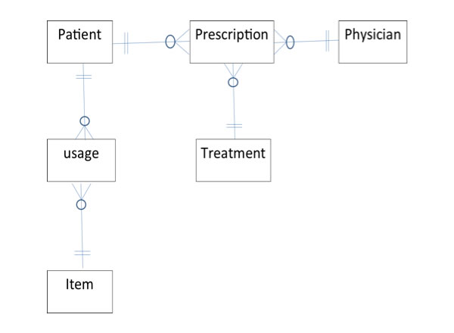
Data volume and access for this diagram are as follows:
- There are 1 000 patients and 500 items yielding a total of 10 000 usage records in the database.
- There are 50 physicians and a total of 4 000 prescriptions in the database.
- There are 200 treatments in the database.
- There are 50 accesses per day for patient records; of these, 30 request access to both prescription and usage records.
- There are 20 accesses per day for physician records; of these, 20 request access to prescriptions.
- There are 50 accesses per day to item records; of these, 10 request access to usage records.
- There are 5 direct accesses per day for treatment records.
- Of the total accesses to prescription records, 20 request access to patients, 30 request access to physicians, and 35 request access to treatment.
- Of the total accesses to usage records, 10 request access to patients and 30 request access to items.
Draw a composite usage map for the RVH database.

Question 2 (15 marks)
Answer the following questions (250 words max/question).
- What are the typical integrity controls performed in both data integrity and referential integrity?
- Using an example for each situation, illustrate the three common situations that suggest relations should be denormalized.
- What are the advantages and disadvantages of horizontal and vertical partitioning?

Question 3 (15 marks)
Answer the following questions (250 words max/question).
- What factors should be considered when choosing a file organization?
- What is the purpose of clustering data in a file?
- Compare hashed file organization versus indexed file organization. List two advantages of indexed over hashed, and two advantages of hashed over indexed.

Question 4 (18 marks)
Consider the following database:
Employee(emp-no, name, department, salary), ProjAssigned(emp-no, proj-no, worked-hours)
- Write one SELECT SQL query to list the numbers and names of all employees with a salary greater than 66 000 who are assigned to projects, the projects they are assigned to, and the corresponding hours worked. Your list should be sorted by employee name.
- Define indexes on selected attributes to speed up your query, and justify your selections.
- Write SQL queries to create the indexes you defined above.

Question 5 (40 marks)
Consider the following three relations:
TRAVEL_AGENT (name, age, salary)
CUSTOMER (name, departure_city, destination, journey_class)
TRANSACTION (number, cust_name, travel_agent_name, amount_paid)
Assume that the attribute “name” in the relations TRAVEL_AGENT and CUSTOMER is a unique identifier (i.e. a string that concatenates ID number, first name, and last name).
Write SQL statements to answer the following questions.
- Compute the number of different customers who have a transaction.
- Display the name of the oldest travel agent.
- List the total number of transactions for each travel agent. Consider only those transactions where the amount paid exceeds 1 000.
- Display the names and ages of the travel agents who have arranged journeys for customer “John Smith”, in descending order of age (use a subquery).
- Display the names and ages of travel agents who have arranged journeys for customer “John Smith”, in descending order of age (do not use a subquery).
- Display the age of travel agents who have arranged journeys for customer “John Smith” to “Ottawa” (use a subquery).
- Display the age of travel agents who have arranged journeys for customer “John Smith” to “Ottawa” (do not use a subquery).
- Display the names and salaries of all travel agents who did not arrange journeys for customer “John Smith”, in ascending order of salary.
- Display the names of travel agents who have five or more transactions.
- Display the names of all travel agents who have arranged at least ten journeys to “Ottawa”.

